PRECISE DIGITAL TEMPERATURE CONTROL

ABSTRACT

The project uses a digital temperature sensor for precise control of temperature in medical applications or industries. This system is better than analog/thermostat system, which has poor accuracy. For example, it can used for temperature control of an incubator where maintaining a precise temperature is very important.
An incubator is an apparatus used to maintain temperature conditions suitable for a neonate (newborn baby) and used particularly for preterm births of babies. This proposed control system provides the temperature information on a display and, when the temperature exceeds the set point, then the load (i.e. heater) switches OFF. In this project a lamp is provided as a load for demonstration purpose.
The system is using a microcontroller of PIC family. Display unit consists of four no’s of seven segment display, and are interfaced to the microcontroller. A digital temperature sensor interfaced to the microcontroller for sensing the temperature conditions. This system also provides four push button switches for adjusting the temperature settings. Then the microcontroller continuously polls the temperature information through a digital temperature sensor and displays over the 7_segment display unit and automatically switches OFF the lamp, when the corresponding temperature exceeds the set point.

BLOCK DIAGRAM
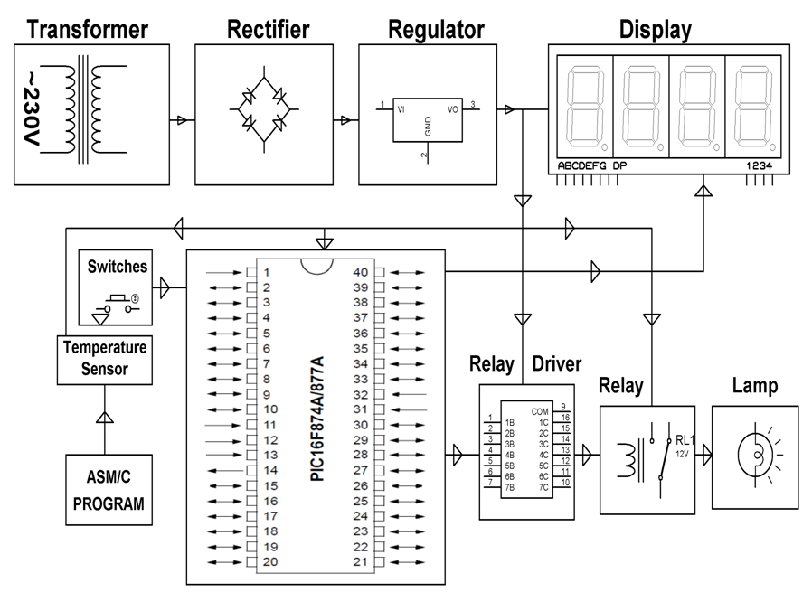
HARDWARE REQUIREMENTS:
PIC series Microcontroller, 7-Segment Displays, Temperature Sensor, Transformer, Crystal, Diodes, Voltage Regulator, LED, Resistors, Capacitors, Push Buttons, Relay, Lamp.

SOFTWARE REQUIREMENTS:
HI-TECH PICC Tool suite
Languages: Embedded C or Assembly

